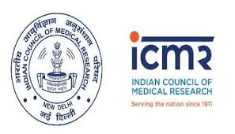

INDIAN COUNCIL OF MEDICAL RESEARCH (ICMR)
ICMR Digital Health Mission invites application to set up Centers for Advanced Research & Excellence (CARE) in the following areas:
- Artificial Intelligence & Machine Learning for Health Care
- m-Health
- Palliative Care
- Biosensors in health care
- Bedside clinical medicine
- Disability and Assistive Technology
- Elderly Care

An application (2 page only) should be in font size 12 and should include a very brief bio sketch of PI (name, date of birth and affiliation of PI), main goal and salient achievements in related area needs to be clearly mentioned. The proposed aim should be in line with the national priorities and may include basic/clinical research but should also highlight the translational value of this CARE.

CARE is usually established around a mid level researcher (40-55 yrs) already established in the area of expertise as evidenced by publications in peer reviewed journals. The primary objective is to support the researcher for pursuing the proposed leads and ideas to their logical conclusions. This support is for 5 years for staff (Scientific, Technical & Supportive), equipments & contingency. The overall budget should not exceed Rs. 5 crores over a period of 05 years. The host Institute has to provide the space & infrastructure for housing this CARE. Host Institute also has to give a commitment to take over the research programmes and continue them beyond the tenure of 05 years. Preference would be given to those applicants who propose to collaborate with any of the ICMR’s 26 institutes.

The applications should be submitted by 5:00 p.m. on 30th April, 2019 after which no application will be entertained. All received applications would be screened by a group of experts and the best applicant in each of the above mentioned categories would be invited to develop a detailed proposal for further review of experts. Decision of DG, ICMR would be final.

For any queries please contact Dr. R. S. Dhaliwal, Ph. No: 011-26588381, email- pschiefncd@yahoo.co.in.

