February 2019

Policy Brief

How can Anthrax outbreaks be prevented in Odisha?

Who is this policy brief for?
Policymakers, their support staff, and other stakeholders with an interest in the problem addressed by this policy brief

Why was this policy brief prepared?
To inform deliberations about health policies and programmes by summarising evidence from a research study conducted by ICMR-RMRC, Bhubaneswar in 4 districts of Odisha - Koraput, Rayagada, Malkangiri and Sundargarh and global evidence on control strategies. It consisted of surveys as well as qualitative interviews with key stakeholders for better understanding of implementation issues

.

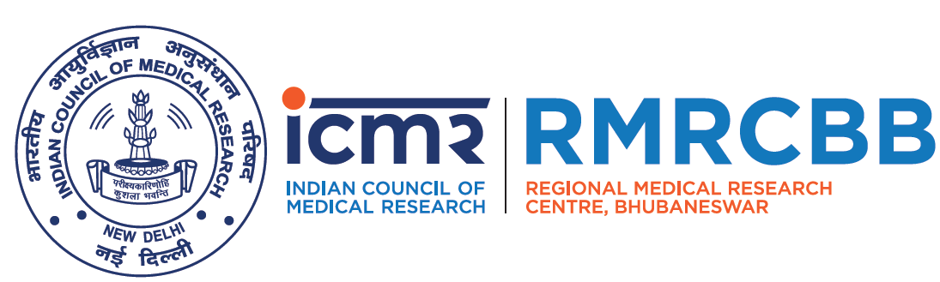

Debdutta Bhattacharya,
Deepika Barla, Sanghamitra Pati

ICMR-Regional Medical Research Centre,
(Department of Health Research,
Ministry of Health and Family Welfare, Govt. of India)
Chandrasekharpur, Bhubaneswar, Odisha, India

Executive summary
Anthrax is a serious infectious disease caused by a bacterium known as Bacillus anthracis. The anthrax bacterium produces spores which can survive for many years in the environment. Anthrax most commonly occurs in wild or domestic animals such as sheep and cattle, but can infect humans causing three types of infections affecting the lungs (pulmonary form), the digestive tract (intestinal form), or the skin (cutaneous form). All types of anthrax can eventually spread throughout the body and cause death if not treated with antibiotics appropriately at appropriate time. Anthrax is most common in agricultural regions of Central and South America, Sub-Saharan Africa, Central and South-western Asia, Southern and Eastern Europe, and the Caribbean. In India, Anthrax infects animals in states like Andhra Pradesh, Jammu and Kashmir, Tamil Nadu, Odisha and Karnataka (NCDC, 2005). During the last 15 years, out of 30 districts in Odisha, 14 districts have witnessed outbreaks of Anthrax affecting at least 1208 people of which 436 had died (Patil 2010 and IDSP, Odisha 2016).
The present policy brief, through a study, tries to identify the possible roadblocks in Anthrax control and management and recommends strategies which could address them in endemic districts of Odisha.
A observational study with mixed method approach was carried out in 4 endemic districts Odisha (Koraput, Rayagada, Sundargarh and Malkangiri) during April-December, 2017. Household survey was carried out with 557 respondents in these 4 districts and in-depth interviews were conducted for the stakeholders of Health, Veterinary, Forest and the Administration.
The study identified that lack of awareness and stigma about Anthrax, illiteracy and poverty, lack of interdepartmental co-ordination, behaviour and food practices among the residents as the main roadblocks in effective management and control of Anthrax in high risk areas of Odisha. The study also highlighted that individuals involved in handling infected animal or carcasses were at high risk of contracting the disease.
We recommend that a) Information Education Communication (IEC) activities with interdepartmental coordination, b) Livestock vaccination with 100% coverage and c) Proper disposal of dead animal/livestock as possible strategies which could be adopted to tackle recurrent outbreaks of Anthrax and related deaths among animal and human.

The problem of anthrax outbreaks
Anthrax is an infectious zoonotic (can be transmitted from animals to humans) disease. It is mainly a disease of cattles, like cow, goat, sheep etc who are infected through soil and feed infected with bacteria. Humans are affected by anthrax through contact with these animals or their products. Contact is by ingestion (mouth), inhalation (through air) or through any cut in the skin and it usually does not spread from one human to another. In humans, Anthrax manifests in three forms- cutaneous (skin), pulmonary (respiratory) and intestinal. Most cases are of cutaneous variety and forms boils-like skin lesions which later forms ulcer with a black centre, with redness around it. These usually occur in the hands or legs. If untreated, risk of death from cutaneous anthrax can go as high as 25% and for the other varieties the risk of death might be up to 75%, even with treatment.
In India, cutaneous, pulmonary and intestinal anthrax accounts for 20%, 30% and 25% death in untreated cases (NCDC, 2006) respectively.

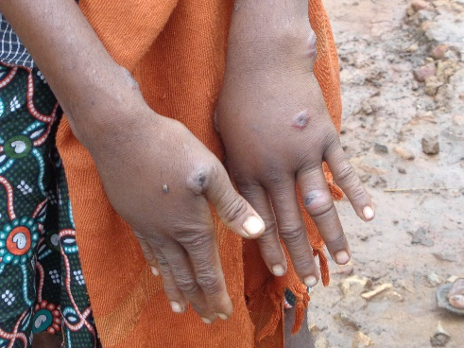
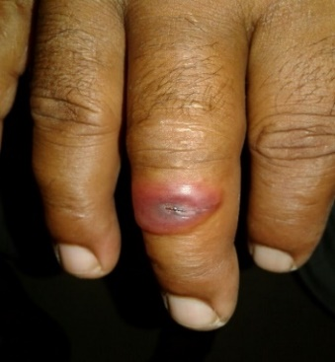
Who are at risk?
People handling infected dead animals and come in contact with infected body fluids while slaughtering, butchering, skinning and consume the infected meat are at risk.

Treatment
Cutaneous anthrax is curable but pulmonary and gastrointestinal are of fatal type. Treatment includes Ciprofloxacin-500, Doxycycline and Penicillin. Anthrax anti-toxin is also often given. If cutaneous Anthrax is untreated it leads to blood infection and multiorgan failure resulting in death.
As per National Animal Diseases Referral Expert System (NADRES) data, Anthrax is one of the top 10 diseases reported in India and one of the major causes of deaths in livestock with high case fatality rate.
High density of tribal population (>22%) and extensive forest cover, makes Odisha highly prone to anthrax outbreaks as meat is the main food item for most of the tribals (Patil, 2010).

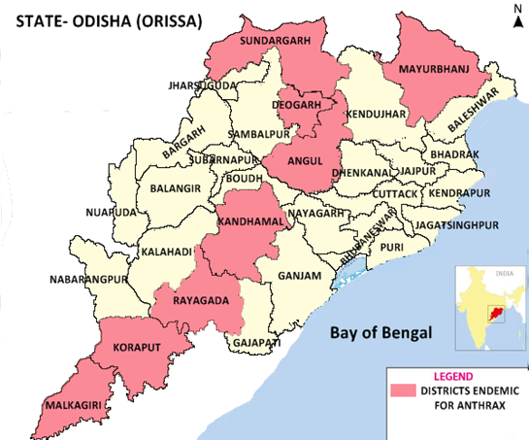
Map of Odisha showing (red color) districts that have experienced outbreaks of human anthrax cases in between 2010-2016 (Source: IDSP, Odisha)

- 19 districts in Odisha are affected with Anthrax
- 8 districts have human Anthrax cases (IDSP)
- Koraput is the most affected with total 354 human Anthrax cases and 9 deaths reported in last 7 years.

Aim & objective
The proposed study was planned to develop a road map to control and prevent the outbreak of Anthrax in the state with the objective to describe the epidemiology and examine the transmission dynamics of Anthrax in Odisha, to explore the socio-cultural practices, to identify the barrier in the prevention and control of anthrax in the state as well as to explore the perspective of key stake holders towards control and management of Anthrax and to assess the health system related factors.

Roadblocks for anthrax control in India: Gap Analysis
Roadblock 1:
Lack of awareness and stigma about Anthrax in villagers
The tribal people are at high risk of developing Human Anthrax as they are involved in dead animal handling and consumption and they are unaware about the diseases and its preventive measures. The survey carried out by the centre revealed about 20% of the respondents were unaware and never heard about the Anthrax disease. Vaccination of cattle is often refused. Often the dead animals are not given to veterinary officials for safe disposal. The present study found 48% of respondents were unaware about the mode of Anthrax transmission.
Due to the lack of awareness and consequent stigma, skin lesions are often hidden, thus delaying diagnosis and leading to further spread.

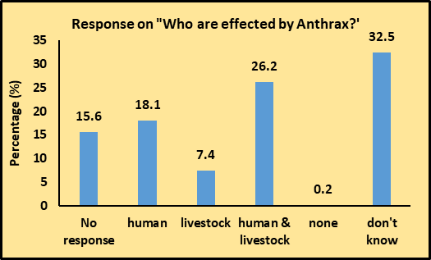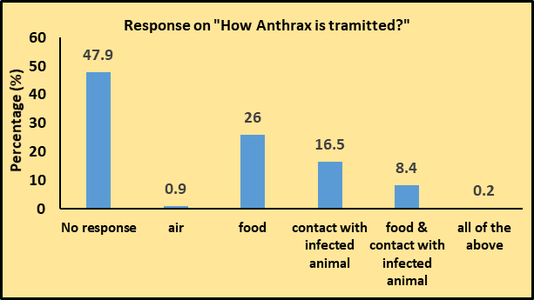
Roadblock 2:
Lack of interdepartmental co-ordination and man power
It is found that mainly health department along with veterinary department work together during the outbreak. Other departments like forest, block administration only attend the meeting during the outbreaks and never part of the control measures for anthrax. Vacant posts at grassroot level in veterinary department also add to the problem as regular anthrax vaccination programmes are compromised and information on cattle deaths are sometimes ignored. Outbreaks gain attention only when it spreads to human.

Roadblock 3:
Behaviour and food practices of people
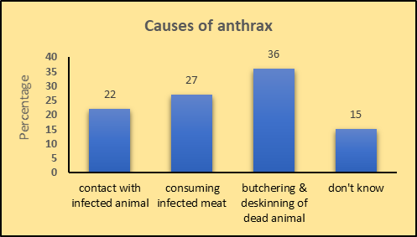
About 18% of the respondents were found to consume dead animals. People dig out the buried animal at night and consume the meat. Meat is dried in sun or in fire and kept hidden for later use. Even the dead animal is consumed over a village get together. These practices are mostly driven by social factors such as poverty and socio-economic losses incurred by loss of cattle and cultural practices (Islam, 2013). About 23% of the respondents admitted to follow practices other than burial of dead animals for disposal. Butchering and deskinning of dead animal accounted for majority (36%) of the Anthrax cases (88) interviewed (Fig 2). Even the skin of the animal is used for drum making or is sold at local market. Trading of cattle is conducted at some places where thousands of cattle are brought from various places which increase the chance for infection.

Figure 2: Practices resulting in Anthrax

Potential recommendations for addressing roadblocks
Recommendations
Awareness programs with interdepartmental coordination about Anthrax outbreaks among high-risk groups:
- Mass awareness camp should be conducted involving all departments like education, health, veterinary, forest & environment, block administration, panchayat members, local NGOs and sarpanch, ward PRI of the village.
Awareness programs & capacity building during
- Block meetings
- Sector meetings
- ASHA/Health worker/Livestock Inspectors/Rangers training schedule

Vaccination:
- Quarterly/half yearly schedule for livestock vaccination in each village for 100% coverage.
- Vaccine should be administered free of cost as charging will further burden the poor tribal population.
Proper disposal of cattle carcasses:
- SOP in local language for disposal to be made available with village panchayat members, ASHA & Livestock Inspector
- Economic incentive/remuneration for reporting and disposal of dead livestock might be effective might cut down the risk of consumption of dead animals.

Next steps

The aim of this policy brief is to encourage dialogue and judgements that are informed by the best available evidence. The intention is not to advocate specific options or close off discussion. Further actions will flow from the careful consideration that the policy brief is intended to inform. These might include:
- A multisectoral approach to identify gaps and address the implementation gaps in control of Anthrax and other zoonotic diseases in the region.
- The recommendations may be adopted in Odisha initially and the may be replicated latter in other states where, Anthrax is endemic.
- Further long-term study to gather more evidence for recommendation for national adaption

Authors
- Dr. Debdutta Bhattacharya
- Ms. Deepika Barla
- Dr. Sanghamitra Pati

Address for correspondence
ICMR-Regional Medical Research Centre, Chandrasekharpur, Bhubaneswar-751023.
Email:
Dr.Sanghamitra Pati: drsanghamitra12@gmail.com
Dr.Debdutta Bhattacharya: drdebdutta.bhattacharya@yahoo.co.in

Acknowledgements: We would like to acknowledge Dr. Soumyadeep Bhaumik of The George Institute for Global Health, New Delhi, for supporting the development of the policy brief and providing inputs on its format and content. The study was part of the Research Capacity Building Programme Award to Dr.D.Bhattacharya, supported by International Development Research Centre, Canada Grant (No-107344-001) to Public Health Foundation of India. The support from Dr.Rajnikant Srivastava, Scientist-F & Head and his team at Division of Research Management, Policy, Planning and Coordination, Indian Council of Medical Research, New Delhi is highly acknowledged.

References:
- Jernigan DB et al. Investigation of Bioterrorism Related Anthrax, United States, 2001: Epidemiologic Findings. Emerg Infect Dis 2002; 8: 1019-28.
- Dutta T et al. (2011). Anthrax- Update on diagnosis and management. The journal of the Association of Physicians of India. 59. 573-8.
- Guidelines for Prevention and Control of Anthrax, Joint publication by World Health Organization, Zoonosis Division, National Institute of Communicable Diseases (Directorate General of Health Services), Delhi, 2006.
- Holty JE et al. Systematic review: a century of inhalational anthrax cases from 1900 to 2005. Ann Intern Med. 2006; 144: 270-80.
- Sitali DC, et al. Awareness and attitudes towards anthrax and meat consumption practices among affected communities in Zambia: A mixed methods approach. PLoS Negl Trop Dis 2017; 11(5): e0005580.
- Patil RR. Anthrax: Public health risk in India and socio-environmental determinants. Indian J Community Med 2010; 35: 189-90.
- Islam S et al. Risk practices for animal and human anthrax in Bangladesh: an exploratory study. Infect Ecol Epidemiol 2013; 3: 21356.
- Centers for Disease Control and Prevention. Use of Anthrax Vaccine in the United States; Recommendations of the Advisory Committee on Immunization Practices (ACIP), 2009. MMWR 2010;59.
- Centers for Disease Control and Prevention. Interim guidelines for investigation of and response to Bacillus anthracis exposures. MMWR Morb Mortal Wkly Rep. 2001;50:987–90.

