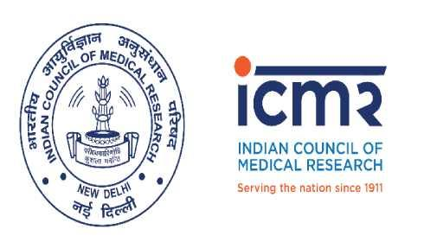

INDIAN COUNCIL OF MEDICAL RESEARCH
Department of Health Research – Ministry Health & Family Welfare
Government of India

Press Release

Japanese Minister visits ICMR to enhance cooperation in Medical Research
28th February 2019, New Delhi
Deputy Minister of Education, Culture, Sports, Science and Technology Government of Japan Mr. Yoshio Yamawaki; today visited Indian Council of Medical Research, headquarters New Delhi.
The visit was regarding exploring future cooperation between India and Japan particularly in Health Research by Indian Council of Medical Research (ICMR) and AMED (Japanese Agency for Medical Research and Development).
Hon'ble Minister met Secretary, Department of Health Research (DHR) & DG ICMR Dr. Balram Bhargava as well as Dr Mukesh Kumar Head International Health Division (IHD) ICMR, Dr. R Gangakhedkar Head ECD ICMR, and Dr. Harpreet Sandhu Scientist (IHD) ICMR discussed regarding the possibility of cooperation in the field of Medical Research.
The Minister was presented with “Touching lives” a Photo- Communication book on the achievements of ICMR and its institutes during last ten years.

With regards,

Syed Adil Shamim Andrabi
Information Interface Officer/PRO
Indian Council of Medical Research-
Department of Health Research
Ministry of Health and Family Welfare
proicmr@gmail.com, syed.adil@icmr.gov.in
Ext. 286, Phone. 26589130

