ICMR/ PR UNIT/IIFO/2019/26
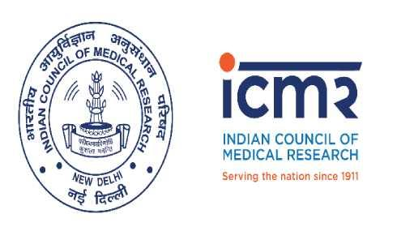

INDIAN COUNCIL OF MEDICAL RESEARCH
Department of Health Research – Ministry Health & Family Welfare
Government of India
Press Release
MoU signed between ICMR and African Union on India Africa Health Sciences Cooperation

27th March 2019, New Delhi
Indian Council of Medical Research (ICMR), Ministry of Health and Family Welfare, Government of India today signed an MoU with the African Union (AU) represented by Scientific Technical and Research Commission (AU-STRC) here in New Delhi. The MoU will strengthen South-South collaboration in advancing health sciences research; enhance local capacity and ownership.
Recognizing the common health challenges faced by limited public health resources the current initiative aspires to intensify cooperation and collaboration to develop cutting-edge, innovative and sustainable solutions catering to the health needs of respective regions of the globe.
The programme would focus on training and strengthening capacity of health professionals, researchers, regulators and industry staff; support research collaborations for developing preventive tools and improved diagnostics for diseases which are regional priorities in India and Africa strengthening product development and manufacturing capacities for drugs and diagnostics.
Dr. Eng. Ahmed Hamdy, Executive Director, AU-STRC said that it is relevant for India and Africa to work synergistically towards shared core priorities by leveraging on existing resources in the achievement of mutual health goals. Our need is to focus on indigenous development of safe, affordable and effective drugs, diagnostics and vaccines towards addressing specific common regional disease burden and nurturing an ecosystem that has a strong impact on transforming the health standards of the population, Dr Hamdy added.
Dr. Balram Bhargava, Secretary DHR and DG, ICMR said that this MoU is a major step to help enrich global health research and stitch it to regional needs of India and Africa. The deliberations charted through series of discussions with leading experts will ensure advancements in strategic and multifaceted regional cooperation to optimize available resources towards contesting shared challenges in health sciences.
India has taken significant strides in extending healthcare cooperation to the African region including pharmaceutical trade and product development, health research and capacity building to fight the scourge of fatal diseases affecting India and Africa. It is imperative to streamline and institute a dynamic framework focused on innovative collaborations that would build on and strengthen current efforts, and leverage on cross-regional strengths to ensure a long-term, sustained India-Africa partnership in health sciences research; Dr Bhargava added.
Dr. Neena Malhotra, JS (E & SA), Ministry of External Affairs, GOI briefed about the initiatives taken by GOI for collaboration between India and many African countries and extended support from MEA to strengthen this MoU.
Dr. S. Eswara Reddy, Drugs Controller General of India, Directorate General of Health Services, Ministry of Health & Family Welfare, GoI highlighted regulatory mechanisms and India’s relationship with several African countries. He expressed interest to facilitate the collaborative arrangements in the ambit of this MoU.
The programme secretariat jointly managed by ICMR and AU-STRC would roll out the implementation plan.

About ICMR: Indian Council of Medical Research is the apex body in India for formulation and coordination of biomedical research. It is an autonomous body under the Department of Health Research, Ministry of Health and Family Welfare (Government of India).
About AU- STRC: The African Union, Scientific, Technical and Research Commission (AU-STRC) is a specialized technical Institute of the African Union and has been at the vanguard of promoting science and technology for the last six (6) decades and deals with science, technology innovation policies, capacity building and research issues for the development of the continent.
With regards,
Syed Adil Shamim Andrabi Dr. Mukesh Kumar
Information Interface Officer/PRO Scientist – ‘G’ & Head International-
proicmr@gmail.com Health Division
syed.adil@icmr.gov.in mukesh.hq@icmr.gov.in
Ext. 286, Phone. 26589130

