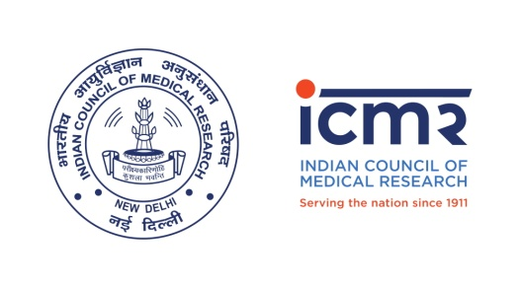
No. 3/1/3/ICMR Chair-Dr. ASP/HRD-2021
Date: 03.09.21
NOTIFICATION
CALL FOR APPLICATIONS FOR THE ICMR-DR. A. S. PAINTAL DISTINGUISHED SCIENTIST CHAIR- 2021
Applications are now invited for the year 2021, for the ICMR-Dr. A.S. Paintal Distinguished Scientist Chair, open to retired medical scientists/medical teachers who may belong to Medical/Bio-medical/Life Sciences field with an excellent track record. There area of contribution should be matched with the priority areas of ICMR. The remuneration of ICMR-Dr. A.S. Paintal Distinguished Scientist Chair will be Rs.1.75 lakh per month and no contingency or secretarial staff. The duration of Chair will be for five years (three years initially, extendable by another two years after assessment of the work progress and future plans). The remuneration will be revised as per the M/o Human Resource Development, Govt. of India (National Research Professor) from time to time. Usually two Chairs will be established at one point of time; their number will not cross five at any given point of time.
Last date to send the applications: 27th September, 2021 (Monday, by 05:30pm)

GENERAL TERMS & CONDITIONS/GUIDELINES
- ICMR Chairs should work preferably, at ICMR Hqrs./Institutes.
- The minimum age limit is 60 years and upper age limit 70 years. However, age relaxation may be considered in exceptionally deserving cases and will be subjected to the decision made by the DG, ICMR only.
- If ICMR Chair visits ICMR Hqrs./Institute to attend meeting or otherwise, accommodation, food and TA shall be provided by the concerned Division/Institute as the case may be.
- No private practice will be allowed during the fellowship period.
- All selected ICMR Chairs need to submit Annual Progress Report (APR), which will be reviewed by concerned Division and recommendation will be submitted to the DG, ICMR.
- All the applicants/nominees are requested to submit their applications along with a research proposal/programme targeting an ICMR priority area which is in line with national health priorities available on ICMR and Department of Health Research (DHR) websites.
- FIVE sets hard copies of the complete applications/nominations may be submitted as per the format given below with all enclosures as required, along with the soft copy as a single PDF file through email to ginu.skhan@icmr.gov.in and copy email to hrdscheme@gmail.com by the deadline given above.
- The applicants may themselves apply or may be nominated by any other Dr. A.S. Paintal Distinguished Scientist of the country as per application format given below.

APPLICATION FORMAT
- Full Name:
- Date of birth:
- Qualifications:
- Research Experience which may be as a scientist/medical/biomedical teacher specially important projects carried out:
- Awards from Govt. of India, State governments, national agencies like ICMR, DST, DBT, CSIR, DRDO, etc.:
- Fellowships from Indian National Science Academy (INSA), National Academy of Sciences India (NASI), Indian Academy of Sciences (IAS), National Academy of Medical Sciences (NAMS), others in this order:
- Significant contributions in the field of Medical Sciences (should be supported by list of publications and documentary evidence):
- Research output after post superannuation:
- Contributions/inputs to National Health Programmes:
- Research Proposal/Programme (about 2-3 typed pages, max. up to 1500 words) that the applicant/nominee would like to carry out - inputs, activities and targeted outcome for first three years and then remaining two years, if extended, with clear plans of utilization of existing infrastructure and human resources of ICMR and or the host institute:
- Any other details that applicant/nominee may like to give in support of his candidature:
- Details of the Proposed host institute, with complete address and with letter of commitment from Head of Institute (duly signed with official seal):

Date: Signature of the Applicant
Place:

The applications to be addressed to:
The Director General
(Kind Attn: Dr. Ginu S. Khan, Scientist-C),
Division of Human Resource Planning and Development,
V. Ramalingaswami Bhawan,
Indian Council of Medical Research Headquarters,
Ansari Nagar, New Delhi-110029
E-mail: ginu.skhan@icmr.gov.in

